|  |  |  |
| --- | --- | --- |
| Name: | Period: | Date: |
| Date Started: | Due Date: | |
| Group Members: | | |
| Advanced Design Applications  Learning Cycle 1: Manufacturing Unit 4  File 1.1 Consumer Data Activity | | |

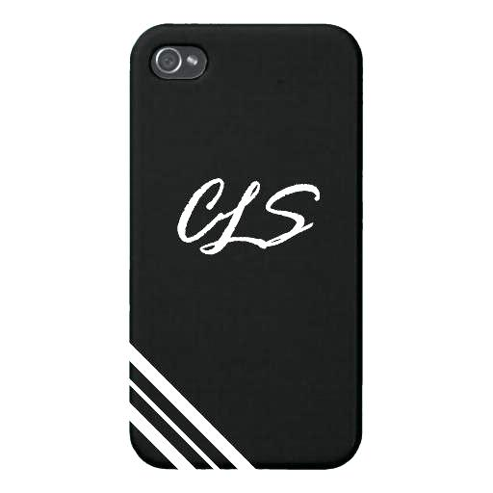**Background**

Before a manufacturer designs a product, the needs of the consumer must be identified. Identifying the needs of your target consumer is crucial for a product’s success. The following three-step process can be used to learn more about your consumers’ needs:

1. Collect information from consumers (market research).
2. Transform the information into consumer needs.
3. Organize the needs into order of importance to the consumer.

New products and innovations are often the result of a company staying in touch with consumer needs. By staying in touch with the criteria consumers use to purchase a particular product, a manufacturer can develop products that are more competitive.

**What to Do:**

Let’s take a look at a common consumer product that many of you own—the smart phone case—and investigate the quality differences between brands. The goal of this activity is to collect enough data to make informed decisions as to which smart phone accessory characteristics are most desirable for potential consumers.

As a class, select three smartphone cases to study. With a partner, examine the selected smartphone cases and decide which shape, size, texture, color, and weight of each cell phone you prefer. Record your and your partner’s preferences in your journals using a table similar to the one below. Be prepared to share your findings with the class so that conclusions can be made about smartphone case preferences.

|  |  |  |  |  |
| --- | --- | --- | --- | --- |
| **Size** | **Shape** | **Texture** | **Color** | **Weight** |
| **Student 1** |  |  |  |  |  |
| **Student 2** |  |  |  |  |  |

As a class, compile the data gathered by individual teams and create a frequency table for each characteristic studied

|  |  |  |
| --- | --- | --- |
| **Smartphone Case #1** | **Smartphone Case #2** | **Smartphone Case #3** |
| **Size** |  |  |  |
| **Shape** |  |  |  |
| **Texture** |  |  |  |
| **Color** |  |  |  |
| **Weight** |  |  |  |
| **Class Size (n)** |  |

**Conclusion Question:**

What characteristics would you combine to create the most popular smartphone cases?